Abalone Data Dictionary
This beginner level data set has 4177 rows and 9 columns and physical measurements of abalones and the number of rings (representing age).
This data set is recommended for learning and practicing your skills in exploratory data analysis, data visualization, and classification modelling techniques.
Feel free to explore the data set with multiple supervised and unsupervised learning techniques. The Following data dictionary gives more details on this data set:

Background:
Abalone (ab-ah-LOW-nee) is a large marine gastropod mollusk. The large sea snail is most often found in the cold waters of New Zealand, Australia, South Africa, Japan, and the west coast of North America. It has extremely rich, flavorful, and highly prized meat that is considered a culinary delicacy. Among the world's most expensive seafood, abalone is often sold live in the shell, frozen, or canned. It is often cut into thick steaks and pan-fried though it can be eaten raw or added to other dishes.
What Is Abalone?
Abalone is a gastropod mollusk that lives in coastal saltwater. A member of the Haliotidae family, it ranges in size from 4 to 10 inches. Like other univalve snails, it has a single shell on top and uses a large foot to cling to rocks and eat algae. The abalone shell is flat and spiral-shaped with several small holes around the edges. Its other names include ear shells and sea ears because of its shell shape. The interior of the shell is an iridescent mother of pearl (nacre) pattern that is as prized as the meat it protects.
The popularity of abalone led to overfishing and nearly brought the shellfish to extinction. Both white and black abalone that live off the California coast are on the endangered species list and it is illegal to gather wild abalone from the oceans in many parts of the world. Due to careful management practices and strict harvesting regulations, wild abalone populations are making a comeback. Farmed abalone is increasingly available.
The age of abalone is determined by cutting the shell through the cone, staining it, and counting the number of rings through a microscope -- a boring and time-consuming task.
Other measurements, which are easier to obtain, are used to predict the age.

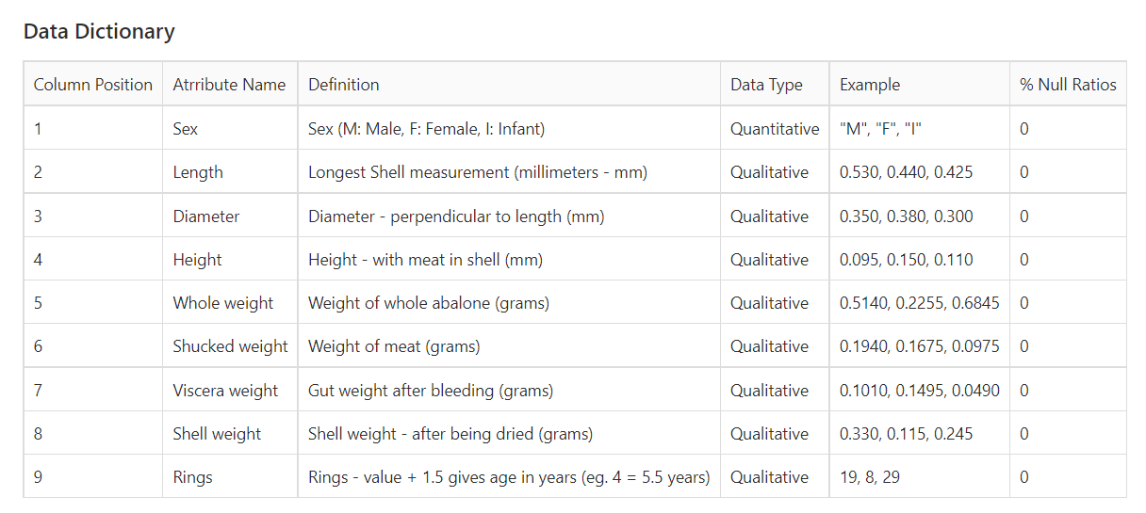

Acknowledgement:
This data set has been sourced from the Machine Learning Repository of University of California, Irvine Abalone Data Set (UC Irvine).
The UCI page mentions the following study as the original source of the data set:
Warwick J Nash, Tracy L Sellers, Simon R Talbot, Andrew J Cawthorn and Wes B Ford (1994) "The Population Biology of Abalone (Haliotis species) in Tasmania. I. Blacklip Abalone (H. rubra) from the North Coast and Islands of Bass Strait", Sea Fisheries Division, Technical Report No. 48 (ISSN 1034-3288)

